Date: 25/03/2026
Report On
Campus to Corporate Grooming: Personality Development

Title: Guest Lecture on "Campus to Corporate Grooming"
Date: 25th March 2026
Venue: Smartboard Classroom, St. Wilfred’s Institute of Pharmaceutical Science & Research, Mira Road.
Introduction
St. Wilfred’s Institute of Pharmaceutical Science & Research, Mira Road organized a guest lecture on "Campus to Corporate Grooming" with the objective of preparing students to meet industry expectations and enhance their professional and interpersonal skills.
Inauguration Ceremony
The program was effectively coordinated by Dr. Satish H. Pandav and Mr. Pranay Shirke (Event Coordinators), ensuring smooth execution of all activities. The program commenced with the presence of esteemed dignitaries including Principal, Prof. Dr. Hemant R. Tawale and the guest speaker Dr. Rasika A. Vaidya, Principal, St. Wilfred’s College of Arts, Commerce and Science, Mira Road. The session began with a traditional lamp lighting ceremony, symbolizing the pursuit of knowledge and wisdom.
Session Highlights
Dr. Rasika A. Vaidya delivered an enriching and interactive session focusing on bridging the gap between academic learning and corporate expectations. The session covered several important aspects such as:
- Interview Skills: Madam guided students on how to confidently face interviews, including preparation strategies, common interview questions, body language, and effective answering techniques.
- Communication Skills: She emphasized the importance of verbal and non-verbal communication, clarity in expression, and professional interaction in the workplace.
- Grooming and Personality Development: Students were trained on professional grooming, dressing sense, confidence building, and maintaining a positive attitude.
- Corporate Etiquette: The session also included guidance on workplace behavior, discipline, teamwork, and adaptability.

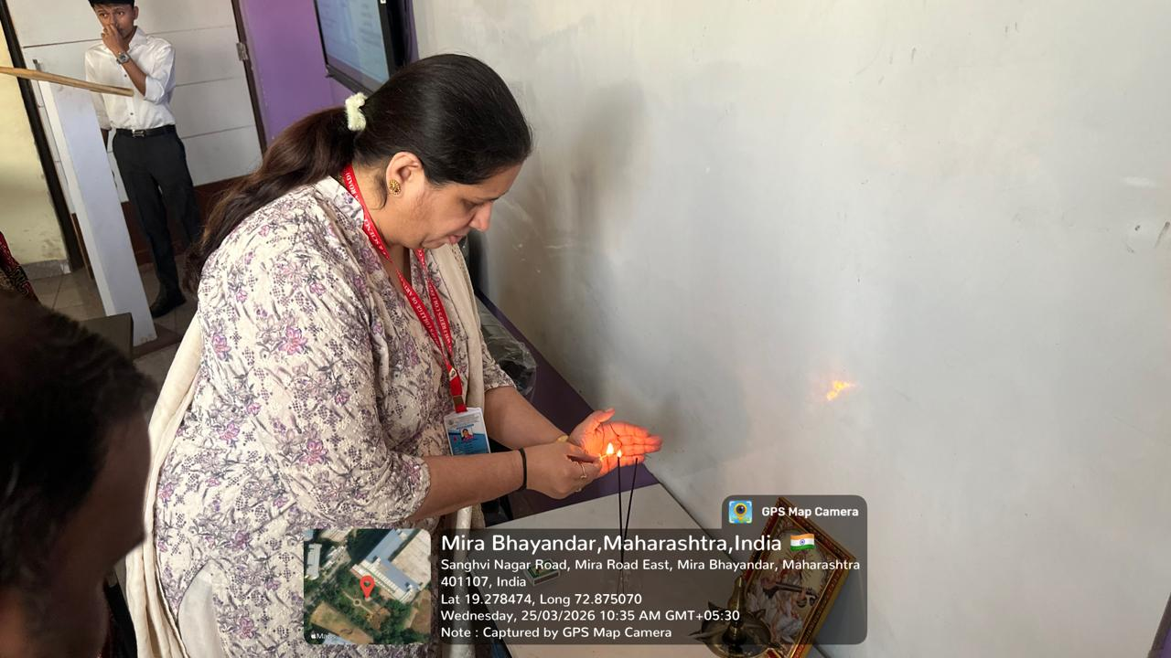 | 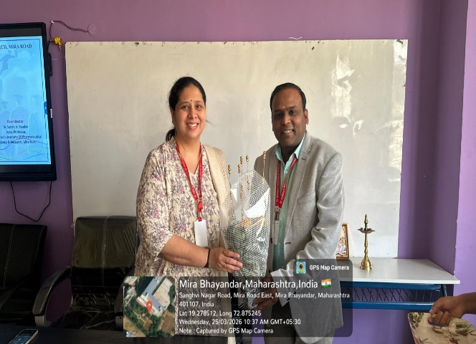
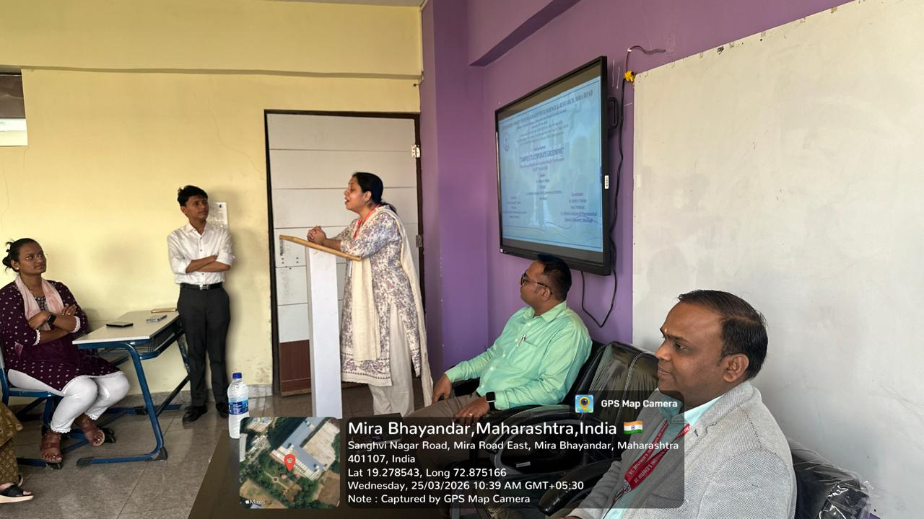 | 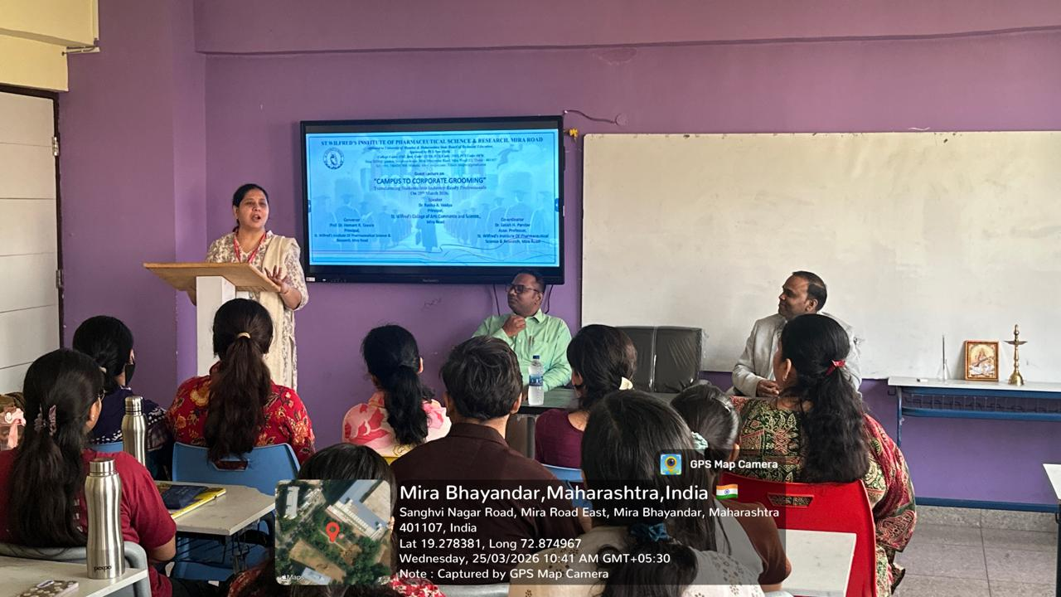
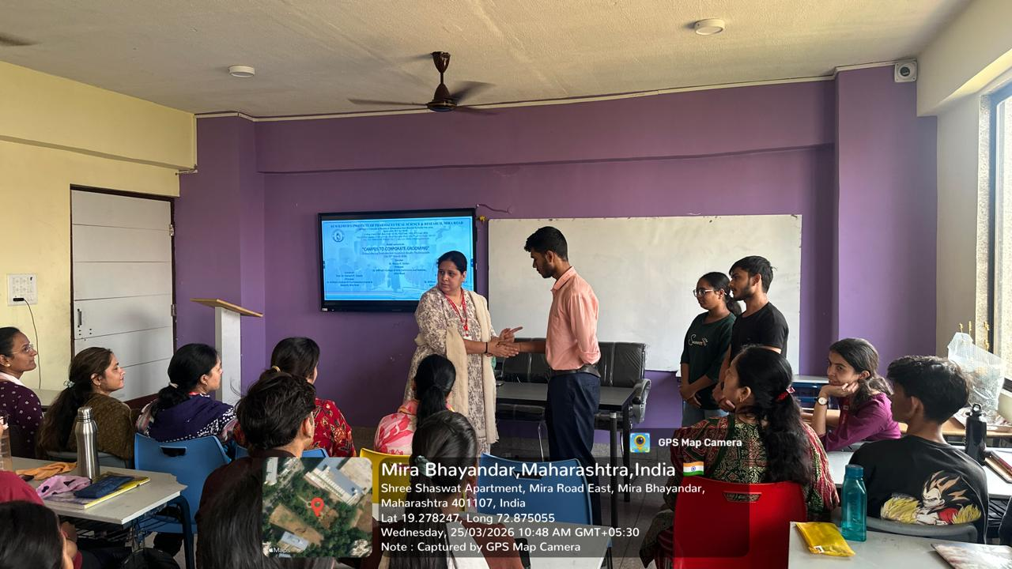 | 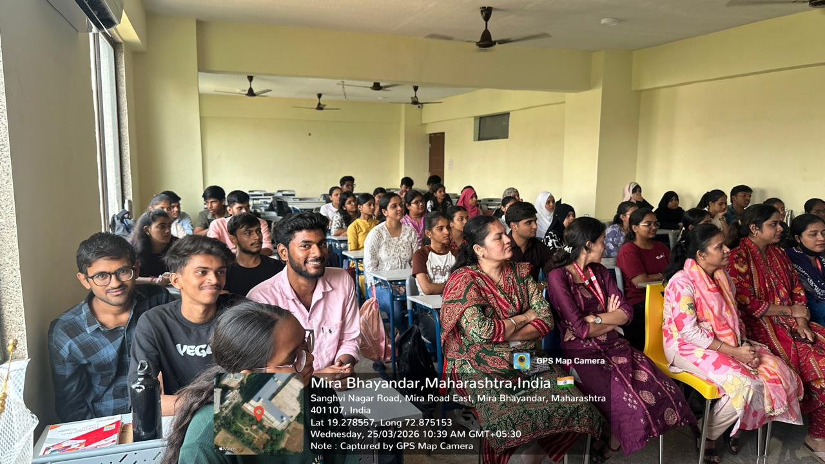

Student Interaction
The session was highly interactive where students actively participated by asking questions and sharing their concerns regarding interviews and career opportunities. Madam provided practical insights and real-life examples which made the session more engaging and beneficial.
Attendance
A total of 60 students and 06 faculty members were present for the session. The active participation of both students and faculty contributed to the success of the program.
Vote of Thanks
The session concluded with a formal vote of thanks delivered by Dr. Satish H. Pandav (Event Coordinator), who expressed heartfelt gratitude to the guest speaker Dr. Rasika A. Vaidya, the Principal, faculty members, and students for their active participation and support. The program was highly informative and helped students gain confidence and clarity about their career path and corporate readiness.
Conclusion
The session concluded with a vote of thanks, expressing heartfelt gratitude to Dr. Rasika A. Vaidya for her valuable time and insightful guidance. The program was highly informative and helped students gain confidence and clarity about their career path and corporate readiness.

Principal
Prof. Dr. Hemant R. Tawale

