Date: 11/12/ 2025

Title: Guest Lecture on “Applied Psychology for Academic Success and Career Growth” Date: 11th December 2025
Venue: Smartboard Classroom, St. Wilfred’s Institute of Pharmaceutical Science &
Research, Mira Road

- Introduction
St. Wilfred’s Institute of Pharmaceutical Science & Research, Mira Road organized a guest lecture on “Applied Psychology for Academic Success and Career Growth” with the objective of enhancing students’ understanding of psychological principles that contribute to academic excellence and professional development. The session aimed to equip students with practical strategies to manage stress, improve focus, and build a positive mindset for career success.

- Inauguration Ceremony
The program commenced with a warm welcome of the guest speaker Dr. Satish H. Pandav, Associate Professor, Konkan Gyanpeeth Rahul Dharkar College of Pharmacy & Research Institute, Karjat. The session began with a formal introduction of the speaker, followed by a brief overview of the importance of psychological well-being in academic and professional life.

- Objectives of the Program
  - To create awareness about the role of psychology in academic performance.
  - To guide students in stress management and emotional balance.
  - To enhance focus, confidence, and motivation among students.
  - To prepare students for career growth using psychological strategies

- Session Highlights
Dr. Satish H. Pandav delivered an insightful and engaging session focusing on the practical
application of psychology in students’ daily lives. The key highlights of the session included:
- Understanding Mindset: Importance of positive thinking and growth mindset for success.
- Stress Management: Techniques to manage academic pressure and anxiety.
- Concentration & Memory: Methods to improve focus, retention, and productivity.
- Time Management: Planning and prioritizing tasks effectively.
- Emotional Intelligence: Managing emotions and developing self-awareness
- Career Readiness: Building confidence, communication, and decision-making skills

- The session was enriched with real-life examples, making it highly relatable and impactful for students.

- Student Interaction
The session was highly interactive, with students actively participating and asking questions related to stress, career confusion, and personal development. Dr. Pandav addressed their queries with practical solutions and motivational guidance, which greatly benefited the students.

- Attendance
A total of 56 students of First Year Diploma in Pharmacy and 6 faculty members attended the session. The active participation contributed to the overall success of the program.

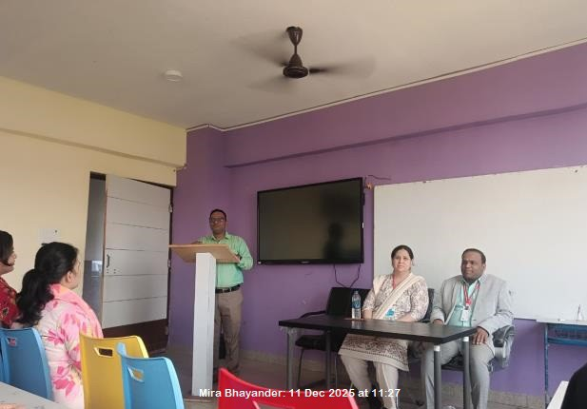 | 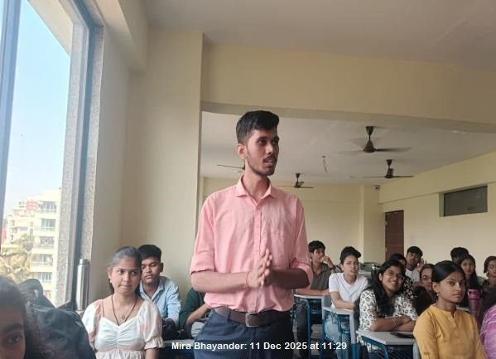
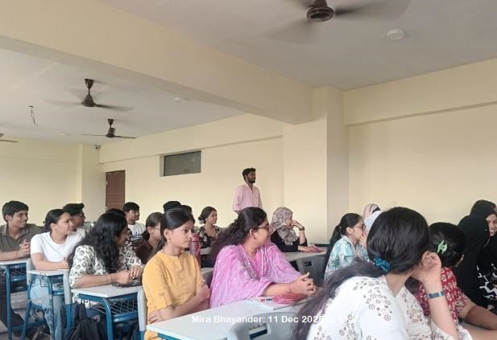 | 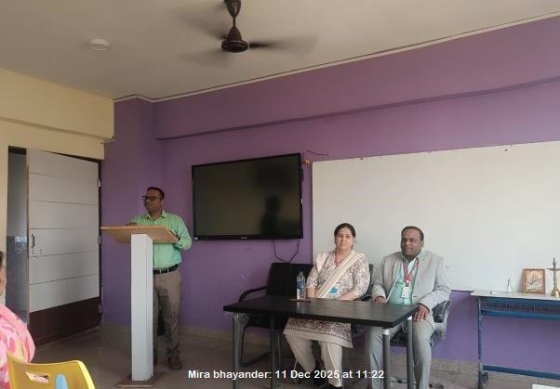

- Conclusion
The session concluded with a formal vote of thanks delivered by Mrs. Radhika Bairagi (Event Coordinator), expressing sincere gratitude to the guest speaker, management, faculty members, and students for their valuable presence and support.

The program was highly informative and inspiring, helping students gain a deeper understanding of psychological approaches to achieve academic success and career growth.

Prof. Dr. Hemant R. Tawale Principal

