Date:
Report On
Training on CIAAN Documentation for D. Pharmacy Faculty

Title: Training on CIAAN (Curriculum Implementation And Assessment Norms) Documentation for D. Pharmacy Faculty
Date: 12th December 2025
Venue: Smartboard Classroom, St. Wilfred’s Institute of Pharmaceutical Science & Research, Mira Road
Resource Person: Prof. Dr. Hemant R. Tawale, Principal

Target Audience:
All Teaching Faculty Members of Diploma in Pharmacy (D. Pharm) Course

Objective of the Programme:
The primary objective of this orientation session was:
- To familiarize faculty with the CIAAN 2023 guidelines
- To understand Outcome-Based Education (OBE) approach
- To ensure effective curriculum implementation
- To guide faculty on assessment strategies and documentation
- To align teaching practices with NEP 2020 and K-Scheme philosophy

An orientation session on Curriculum Implementation and Assessment Norms (CIAAN) was successfully conducted at St. Wilfred’s Institute of Pharmaceutical Science & Research, Mira Road for the Diploma in Pharmacy (D. Pharm) faculty members. The session was delivered by Prof. Dr. Hemant R. Tawale, Principal of the institute, with the objective of strengthening academic delivery, ensuring effective curriculum implementation, and aligning teaching-learning practices with the Outcome-Based Education (OBE) framework as prescribed by MSBTE under the K-Scheme.

Session Highlights:
The Dr. Hemant Tawale initiated the session by emphasizing the significance of CIAAN 2023 as a structured framework that ensures uniformity, quality, and accountability in technical education. He elaborated that CIAAN is not merely a guideline document but a comprehensive academic system that integrates planning, delivery, assessment, documentation, and continuous improvement. He highlighted that the role of faculty is crucial in translating curriculum objectives into measurable student outcomes, thereby contributing to the holistic development of learners.

During the session, detailed insights were provided on Outcome-Based Education (OBE), where the focus shifts from traditional teaching to student-centric learning. Dr. Tawale explained the importance of defining clear Course Outcomes (COs), Program Outcomes (POs), and aligning them with teaching methodologies and assessment tools. He stressed that faculty members must design their teaching plans in such a way that students acquire not only theoretical knowledge but also practical skills, critical thinking abilities, and industry readiness.

Further, the Principal elaborated on the structure of the K-Scheme curriculum, which includes theory, practical, tutorial, and self-learning components. He explained the importance of micro-projects, assignments, and active learning strategies in enhancing student engagement. Special emphasis was given to innovative teaching practices such as experiential learning, ICT-enabled teaching, and real-life application-based instruction to improve learning outcomes.
A significant portion of the session was dedicated to understanding the assessment system under CIAAN. Dr. Tawale explained the implementation of formative and summative assessments, including continuous evaluation through class tests, assignments, practical performance, and micro-projects. He also guided faculty on maintaining transparency, consistency, and fairness in evaluation, along with proper documentation of assessment records as per prescribed proformas.

Dr. Tawale also highlighted the importance of academic documentation and record maintenance. He guided faculty members on preparing teaching plans, maintaining course files, recording student performance, analyzing results, and documenting corrective actions. He explained that proper documentation plays a vital role during academic audits, inspections, and accreditation processes, ensuring evidence-based evaluation of institutional performance.

The session also covered the academic monitoring mechanism, including the role of the Institution Curriculum Implementation and Quality Assurance Cell (ICIQAC). Dr. Tawale emphasized the need for regular review meetings, feedback collection, and continuous improvement strategies to maintain academic excellence. He encouraged faculty to actively participate in quality assurance activities and contribute to institutional growth.

An interactive discussion session was conducted wherein faculty members raised queries related to implementation challenges, assessment criteria, and documentation practices. Dr. Tawale addressed all queries with practical examples and provided clear guidance, ensuring that faculty members gained confidence in implementing CIAAN norms effectively.

The orientation session proved to be highly informative, insightful, and beneficial for all faculty members. It enhanced their understanding of CIAAN 2023 norms and equipped them with the necessary knowledge and skills to implement outcome-based education effectively. The session also reinforced the importance of structured academic planning, continuous assessment, and quality assurance in achieving academic excellence.
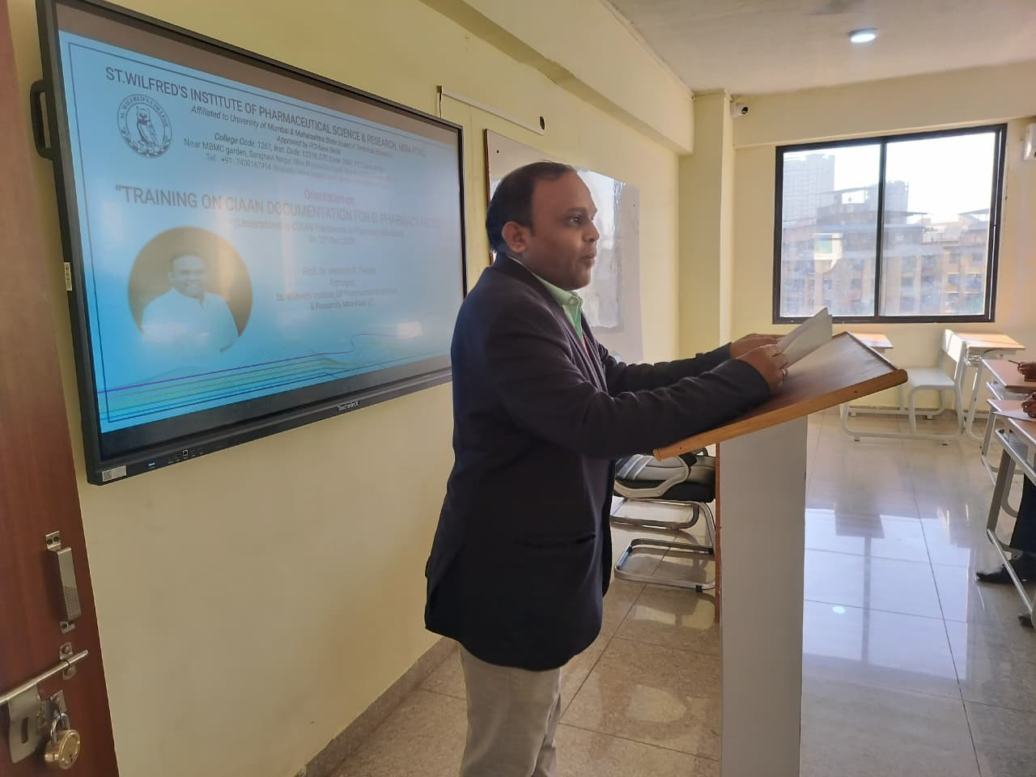 | 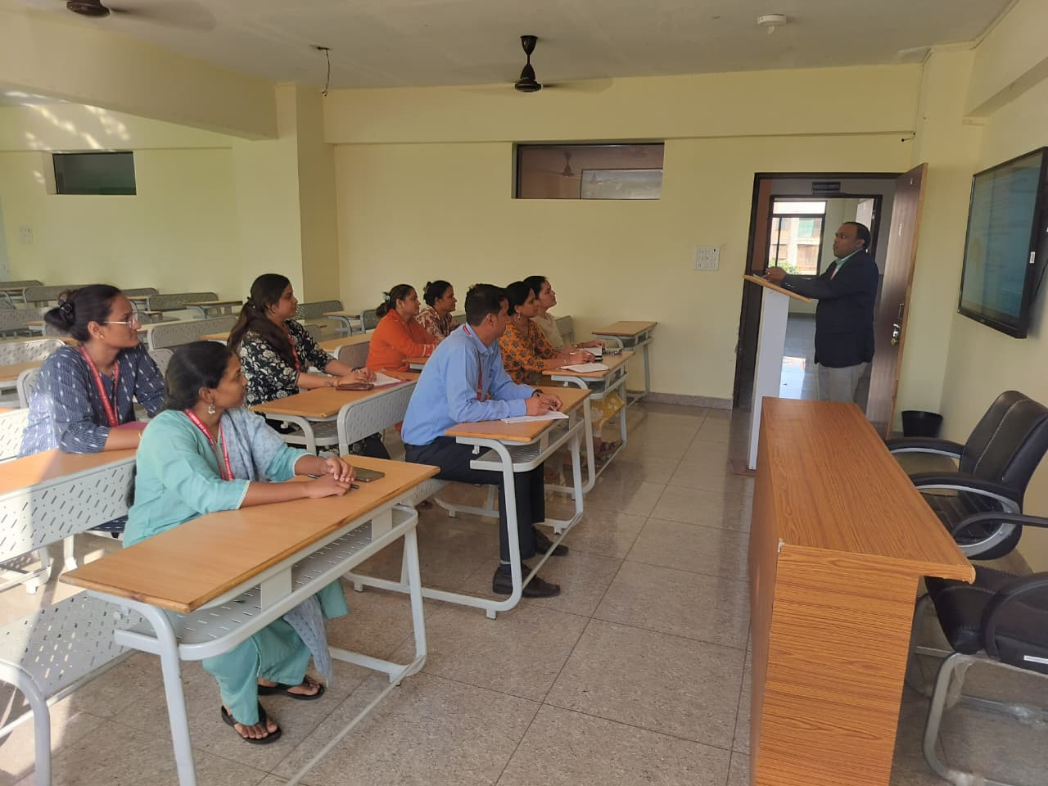
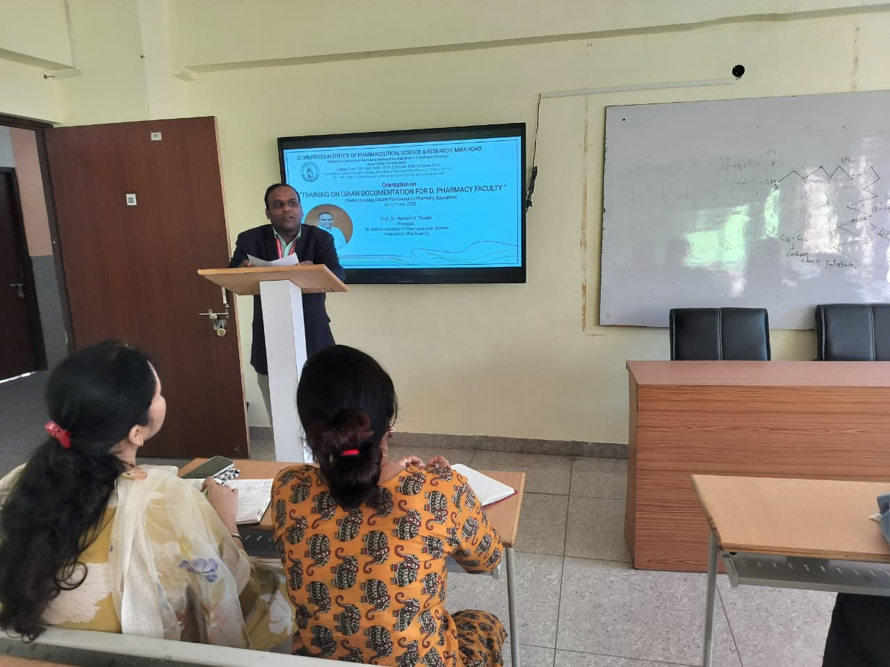 | 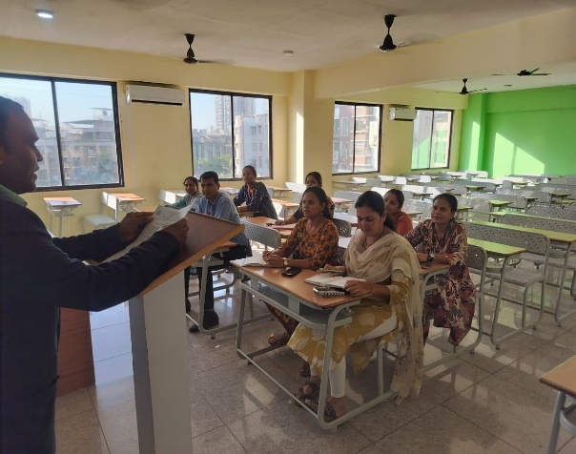

The programme concluded with a vote of thanks, expressing sincere gratitude to Prof. Dr. Hemant R. Tawale for his valuable guidance and for delivering an enriching and impactful session. The faculty members appreciated the session and expressed their commitment to implementing the CIAAN guidelines effectively in their teaching practices.

Principal
Prof. Dr. Hemant R. Tawale

